1. Consider the two matrices: A=[1 0 1; 2 3 4; –1 6 7] B = [7 4 2; 3 5 6; –1 2 1]

Using MATLAB, determine the following: (a) A + B (b) AB (c) A2 (d) AT (e) B–1 (f) BTAT (g) A2 + B2 – AB (h) determinant of A, determinant of B and determinant of AB.

Solution:

A = [1 0 1; 2 3 4; –1 6 7];

B = [7 4 2; 3 5 6; –1 2 1];

C = A + B

D = A*B

E = A^2

F=A’

H=inv(B)

J = B'*A'

K = A^2 + B^2 – A*B

L=det (A); M=det (B); N=det(A*B)

Result:

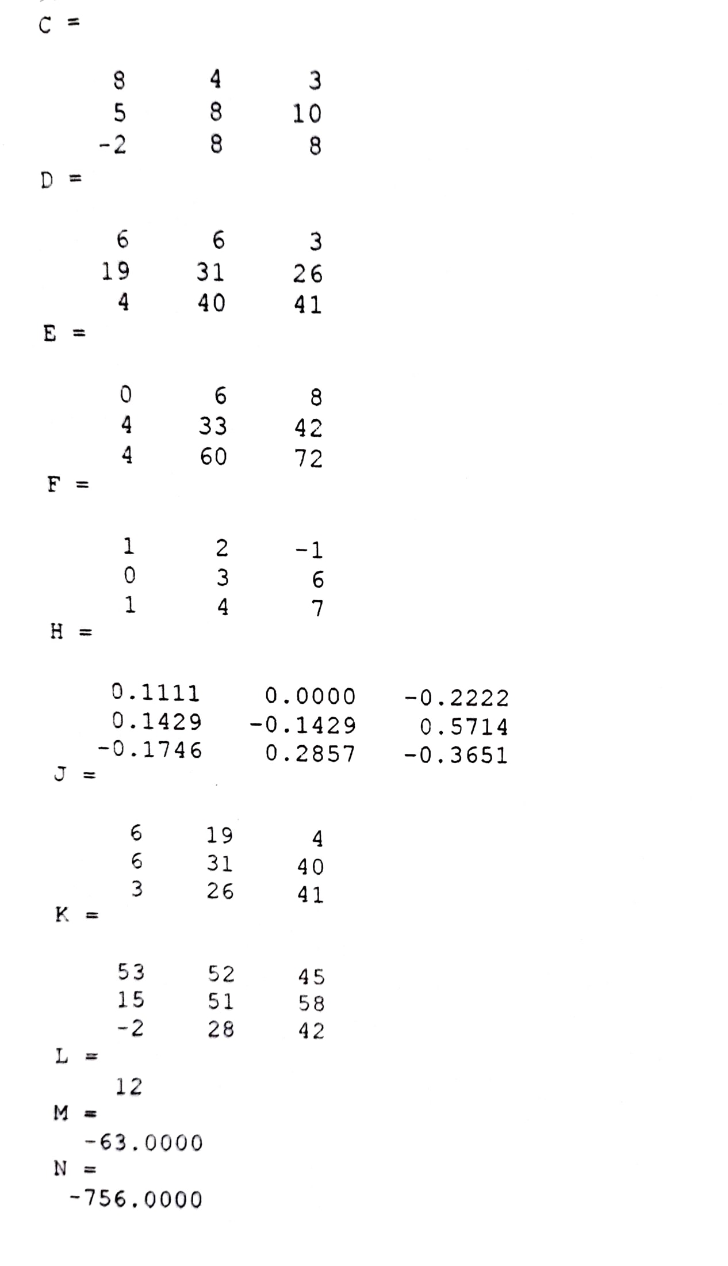

2. Determine the values of x, y and z for the following set of linear algebraic equations: x2 – 3x3 = –5 2x1 + 3x2 – x3 = 7 4x1 + 5x2 – 2x3 = 10

Solution:

A = [0 1 –3; 2 3 –1; 4 5 –2];

B = [–5; 7; 10];

x = A\B

Result:

x = –1

4

3

3. Generate an overlay plot for plotting three lines

y1 = sin t

y2 = t

y3 = t – t^3/3! + t^5/5! + t^7/7! ; 0 ≤ t ≤ 2π

Solution:

t = linspace(0, 2*pi, 100);

y1 = sin(t); y2 = t; y3 = t -(t.^3)/6 + (t.^5)/120-(t.^7)/5040;

plot(t, y1, t, y2, '-', t, y3, 'o')

axis([0 5 -1 5])

xlabel('t')

ylabel('sin(t) approximation')

title('sin(t) function')

text(3.5,0, 'sin(t)')

gtext('Linear approximation')

gtext('4-term approximation')

Result:

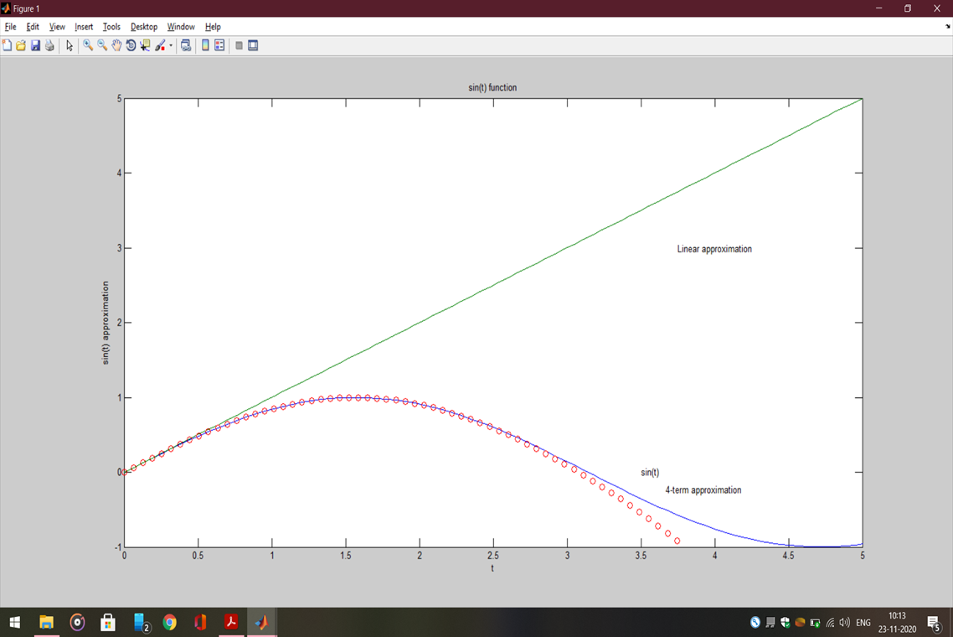

4. Generate a plot of y(x) = e(–0.7x) sin ωx where ω = 15 rad/s, and 0 ≤ x ≤ 15. Use the colon notation to generate the x vector in increments of 0.1.

Solution:

x=[0:0.1:15];

w=15

y=exp(-0.7*x).*sin(w*x)

plot(x,y)

xlabel('x');

ylabel('y');

title('y(x)=e^-^0^.^7^xsin\omegax')

Result:

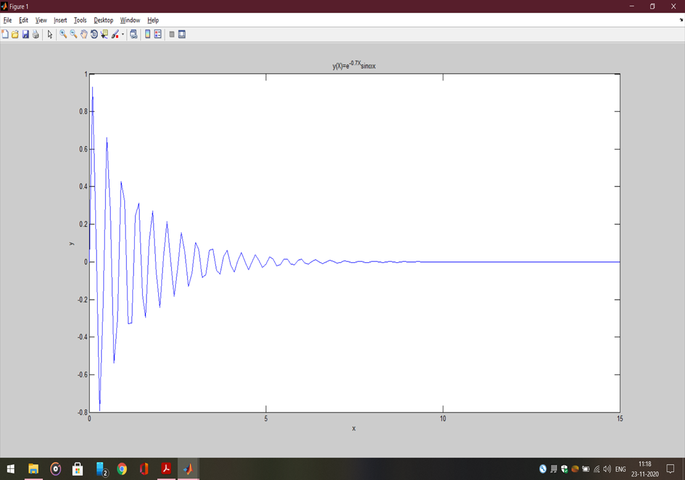

5. Generate a plot of y(x) = e–0.6x cos ωx where ω = 10 rad/s, and 0 ≤ x ≤ 15. Use the colon notation to generate the x vector in increments of 0.05.

Solution:

x=[0:0.1:15];

w=10

y=exp(-0.6*x).*cos(w*x);

plot(x,y)

xlabel('x')

ylabel('y')

title('y(x)=e^-^0^.^6^xcos(\omega x)')

Result:

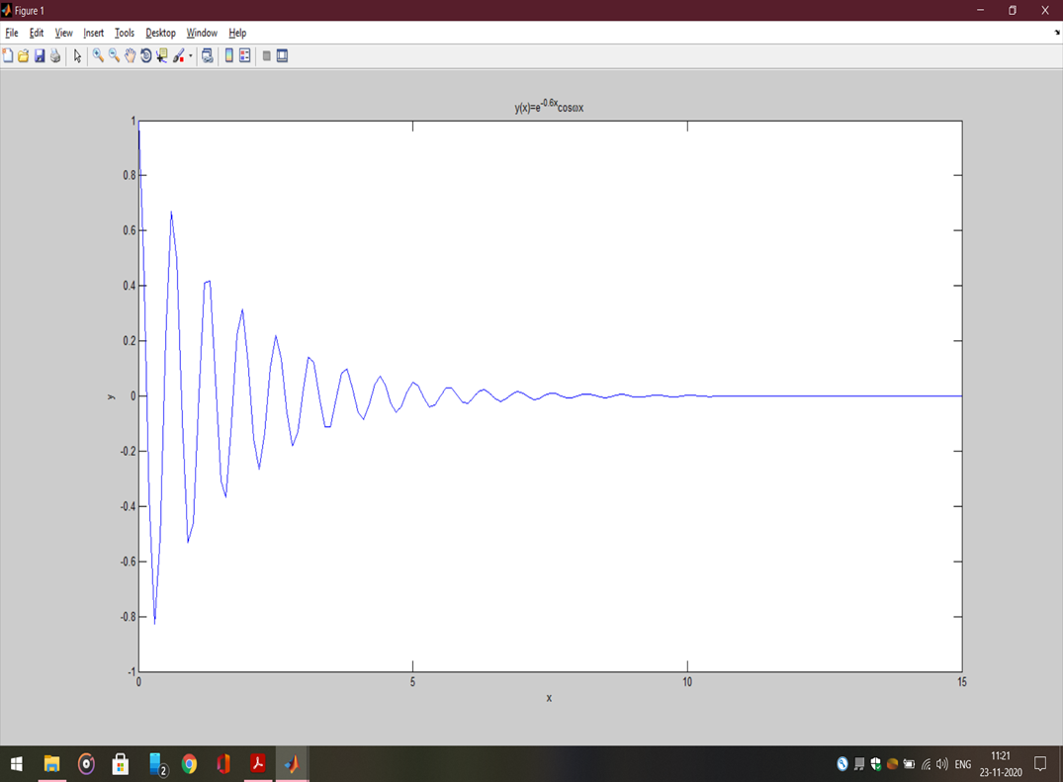

6. Using the functions for plotting x-y data given in table 1.29, plot the following functions

(a) r2 = 5 cos 3t; 0 ≤ t ≤ 2π

(b) r2 = 5 cos 3t; 0 ≤ t ≤ 2π

Sol:

(a)

t = linspace(0,2*pi,200);

r = sqrt(abs(5*cos(3*t)));

polar(t,r)

Result:

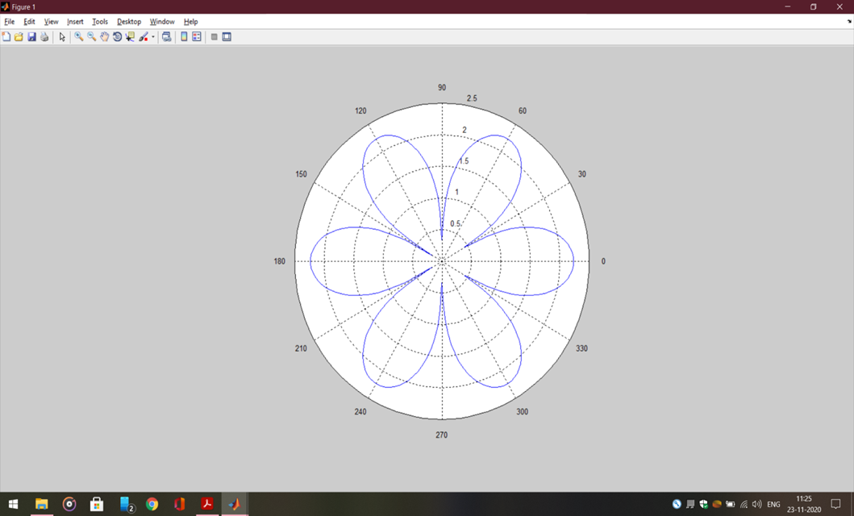

(b)

t=linspace(0, 2*pi, 200);

r=sqrt(abs(5*cos(3*t)));

x=r.*cos(t); y=r.*sin(t);

fill(x, y, 'k');

axis('square');

Result:

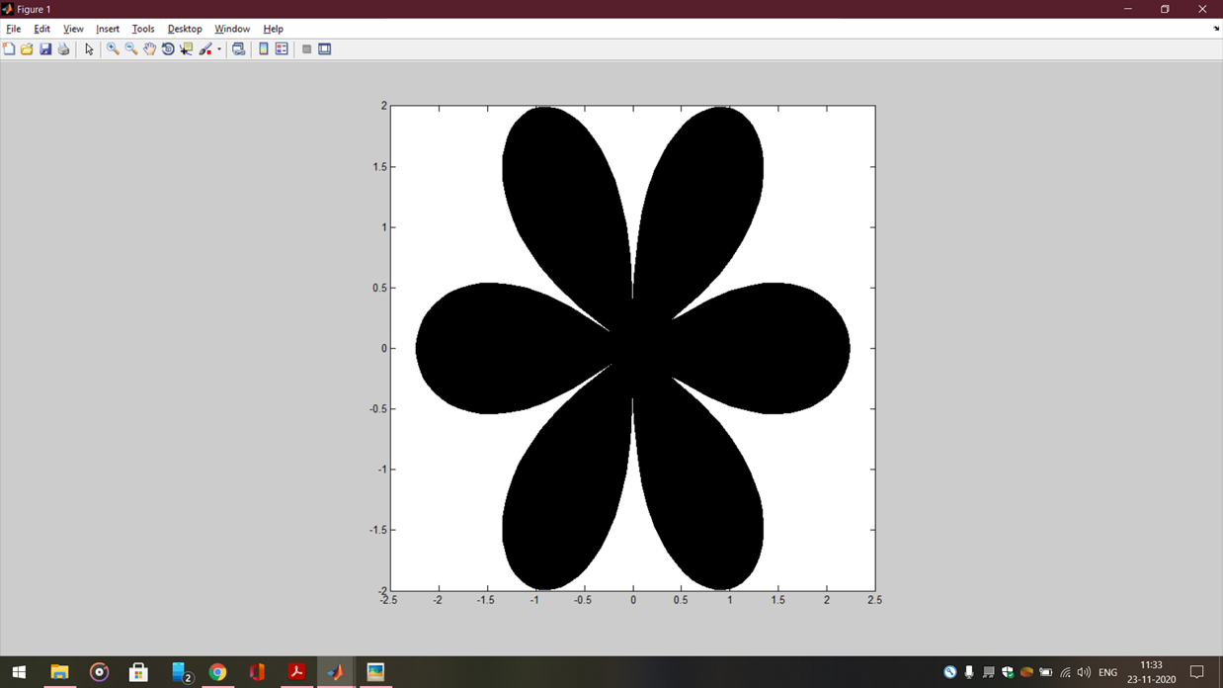

7. Solve the following set of equations using MATLAB:

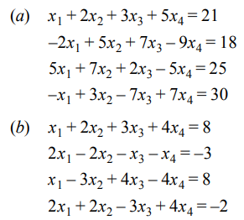

Solution:

(a) A = [1 2 3 5;-2 5 7 -9; 5 7 2 -5; -1 -3 -7 7];

B = [21; 18; 25; 30];

S = A\B

(b) A = [1 2 3 4; 2 –2 –1 1; 1 –3 4 –4; 2 2 –3 4];

B = [8; –3; 8;–2];

S =A\B

Result:

(a)S =

-8.9896

14.1285

-5.4438

3.6128

(b) S =

2.0000

2.0000

2.0000

-1.0000

8. Use diff command for symbolic differentiation of the following functions:

(a) S1 = ex^8

(b) S2 = 3x3 ex^5

x(c) S3 = 5x3 – 7x2 + 3x + 6

Solution:

(a) syms x

S1 = exp(x^8)

diff(S1)

Result: 8*x^7*exp(x^8)

(b) S2 = 3*x^3*exp(x^5)

Diff(S2)

Result: 9*x^2*exp(x^5) + 15*x^7*exp(x^5)

(c) S3=5*x^3-7*x^2+3*x+6

diff(S3)

Result: 15*x^2 - 14*x + 3

9. Use MATLAB’s symbolic commands to find the values of the following integral: 

Solution: syms x

S1 = abs(x)

int(S1,0.2,0.7)

Result:

S1 =

abs(x)

ans =

9/40

10. Obtain the general solution of the following first order differential equations:



Solution:

(a) solve('Dy=5*t-6*y')

Result:

ans =

(5*t)/6 - Dy/6

(b) dsolve('D2y+3*Dy+y=0')

Result:

ans =

C2*exp(t*(5^(1/2)/2 - 3/2)) + C3*exp(-t*(5^(1/2)/2 + 3/2))

11. Determine the solution of the following differential equations that satisfies the given initial conditions.



Solution: dsolve('Dy=-7*x^2','y(1)=0.7')

Result:

ans =

7*x^2 - 7*t*x^2 + 7/10

12. Equivalent force system (addition of vectors). Three forces are applied to a bracket as shown. Determine the total force applied to the bracket.

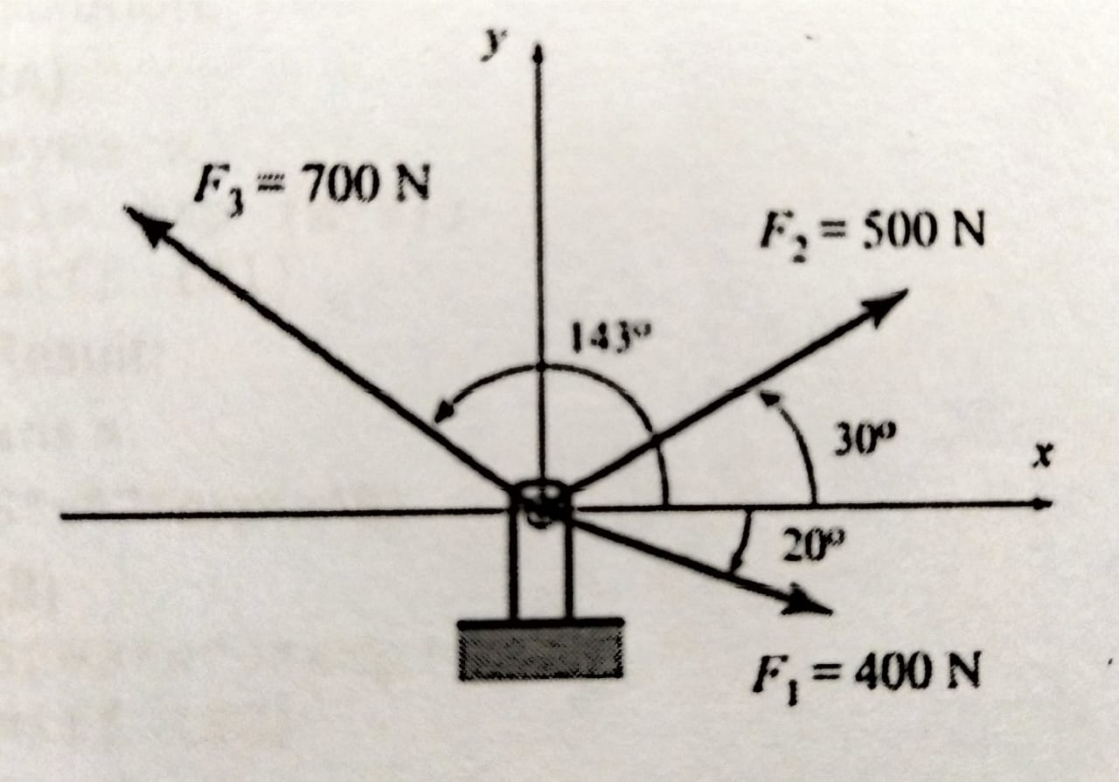

Solution: F1M=400; F2M=500; F3M=700;

Th1=-20; Th2=30; Th3=143;

F1=F1M*[cosd(Th1) sind(Th1)]

F2=F2M*[cosd(Th2) sind(Th2)]

F3=F3M*[cosd(Th3) sind(Th3)]

Ftot=F1+F2+F3

FtotM=sqrt(Ftot(1)^2+Ftot(2)^2)

Th=atand(Ftot(2)/Ftot(1))

Result: F1 =

375.8770 -136.8081

F2 =

433.0127 250.0000

F3 =

-559.0449 421.2705

Ftot =

249.8449 534.4625

FtotM =

589.9768

Th =

64.9453

13. The coefficient of friction µ, can be determined by µ = F/mg where F is the measured force (N), m is the mass (kg) and g = acceleration due to gravity (9.81 m/s2). The following table gives the experimental data. Determine (a) the coefficient of friction in each test (b) the average from all tests.

|  |  |  |  |  |  |  |
| --- | --- | --- | --- | --- | --- | --- |
| Test | 1 | 2 | 3 | 4 | 5 | 6 |
| Mass m (kg) | 2 | 4 | 5 | 10 | 20 | 50 |
| Force F (N) | 12.5 | 23.5 | 30 | 61 | 117 | 294 |

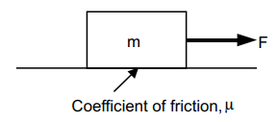

Solution: m = [2 4 5 10 20 50];

F = [12.5 23.5 30 61 117 294];

mu=F./(m*9.81)

Result: mu =

0.6371 0.5989 0.6116 0.6218 0.5963 0.5994

14. Write a MATLAB program that calculates and plots the position, velocity and acceleration of the piston for one full revolution of the crank. Assume that the crank is rotating at a constant speed of 500 rpm. Given radius of crank = 120 mm and radius of crank shaft = 250 mm

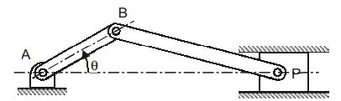

Solution:

N=550;r=0.125; c=0.250;

TD=N*2*pi/60; tf=2*pi/TD

t=linspace(0,tf,200);

TH=TD*t;

d2s=c^2-r^2*sin(TH).^2;

x=r*cos(TH)+sqrt(d2s);

xd=-r*TD*sin(TH)-(r^2*TD*sin(2*TH))./(2*sqrt(d2s));

xdd=-r*TD^2*cos(TH)-(4*r^2*TD^2*cos(2*TH).*d2s+(r^2*sin(2*TH)*TD).^2)./(4*d2s.^(3/2));

subplot(3,1,1)

plot(t, x)

grid

xlabel('Time (s)')

ylabel('Position (m)')

subplot(3,1,2)

plot(t, xd)

grid

xlabel('Time (s)')

ylabel('Velocity (m/s)')

subplot(3,1,3)

plot(t, xdd)

grid

xlabel('Time (s)')

ylabel('Acceleration (m/s^2)')

Result:

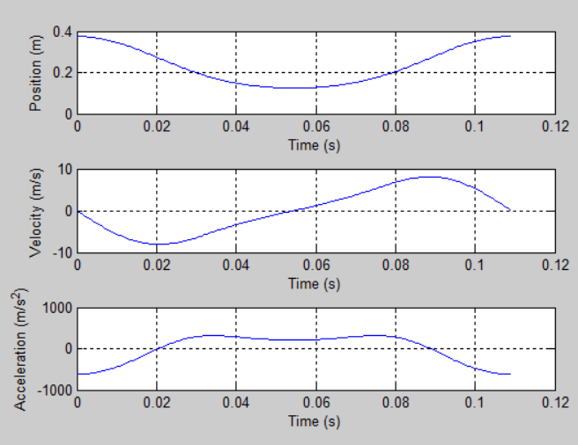

15. Plot the transmissibility curve.

Solution:

for i=1:6

zeta=i*0.2;

zz(i)=zeta;

for j=1:61

x(j)=(j-1)*0.1;

y(j,i)=sqrt(((1+2*zeta*x(j)).^2)/(((1-x(j).^2).^2+(2*zeta*x(j)).^2)))

end

end

for i=1:61

z1(i)=y(i,1)

z2(i)=y(i,2)

z3(i)=y(i,3)

z4(i)=y(i,4)

z5(i)=y(i,5)

z6(i)=y(i,6)

end

plot(x,z1,x,z2,x,z3,x,z4,x,z5,x,z6)

xlabel('frequency')

ylabel('Ft/kY')

Result:

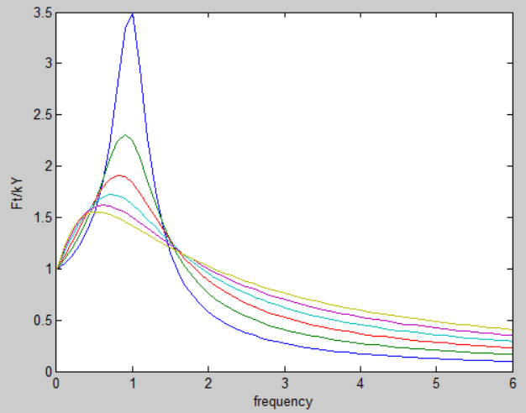

16. Figure shows a weight W hung from the end of a horizontal pole of negligible weight. The pole is attached to the wall by a pivot and is supported by a cable attached to the wall at a higher point. The tension T, in the cable is given by

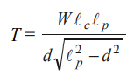

where T = tension in the cable, W = weight of the object, Ac = length of the cable, Ap = length of the pole and d = distance along the pole at which the cable is attached. Write a MATLAB program to (a) determine the distance (d) at which the cable can be attached to the pole in order to minimize the tension in the cable, (b) plot the tension in the cable as a function of d.

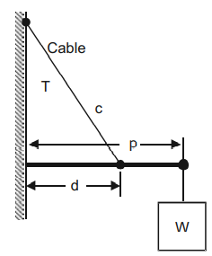

Solution:

lc=0.40;

lp=0.50;

W=250;

d=0.05:0.05:lp;

T=W*lc*lp./(d.*sqrt(lp^2-d.^2));

plot(d*100,T,'-p');

xlabel('Distance d in cm');

ylabel('Tension in string in N');

grid on;

[Tmin, I]=min(T);

fprintf('Minimum tension is %g N at %g cm',Tmin,d(I)*100)

Result:

Minimum tension is 400.08 N at 35 cm>>

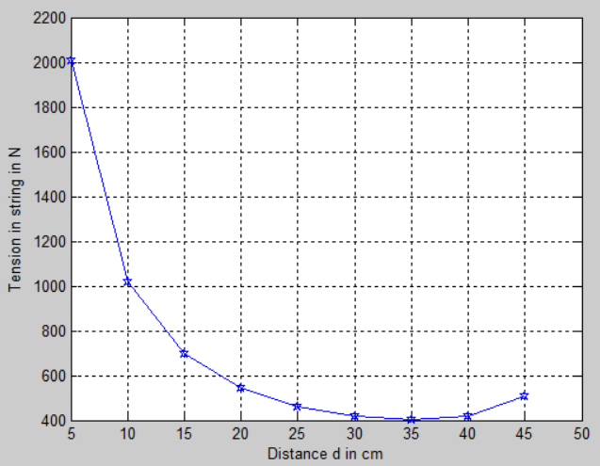

17. Figure shows the location of the center of gravity of a 5000 N truck for the unloaded condition. The location of the added load WL is at a distance of x inches behind the rear axle. Write a MATLAB program and plot WL as a function of x for x ranging from 0 to 60 mm.

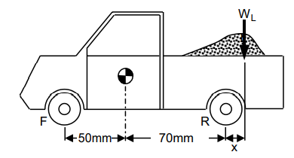

Solution:

x = 0:0.05:60;

Wl=5000./(60 + x);

plot(x, Wl)

xlabel ('x (mm)')

ylabel ('Load weight (N)')

grid on;

Result:

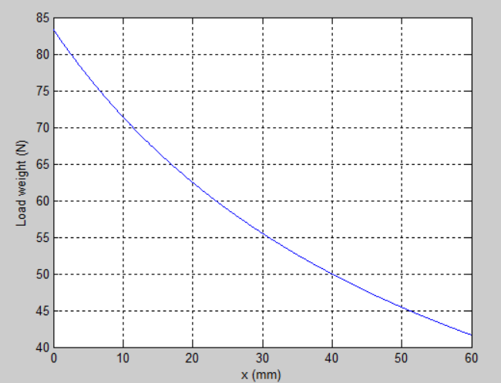

18. Simulink modelling of a spring mass damper system.

Solution:

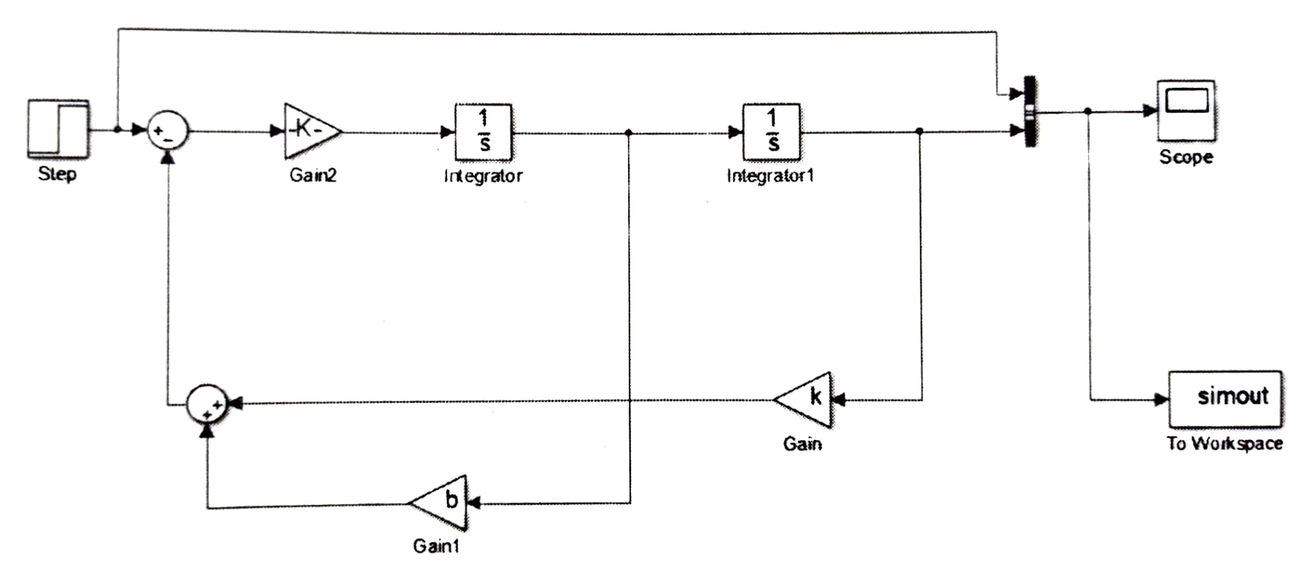Result:

